Matthew Muller

**Certificate Generation Assignment**

A certificate authority (CA) is a trusted organization that issues digital certificates through the validation of the entities involved, such as websites or individuals. These digital certificates are typically issued after an applicant generates a key pair that consists of a private key and a public key, as well as a certificate signing request (CSR). After receiving an application, the CA will verify that the information in the CSR is correct, usually through a partnership with a financial institution that helps them to authenticate the identity of the applicant. If the information is verified to be correct, the CA digitally signs the certificate with its own private key. This effectively secures the website that receives the certificate because it ensures that any information that a user receives was sent by someone in possession of the private key issued by the CA, thus proving their identity.

One of the biggest benefits of using a CA to generate certificates is that it proves that your site is trustworthy. Since CAs are trusted third-party organizations, having them validate your website as the real thing provides users with a level of confidence in their security that helps to improve the quality of your website. With a self signed certificate, the entities creating the certificate are signing off for themselves. This makes these certificates much less trustworthy, especially over public networks. By going through a CA, you prove that your website is secure and this can be shown to users by the HTTPS padlock symbol that a CA-signed certificate earns you.

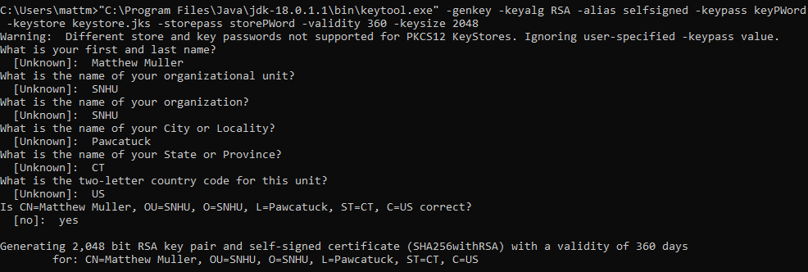

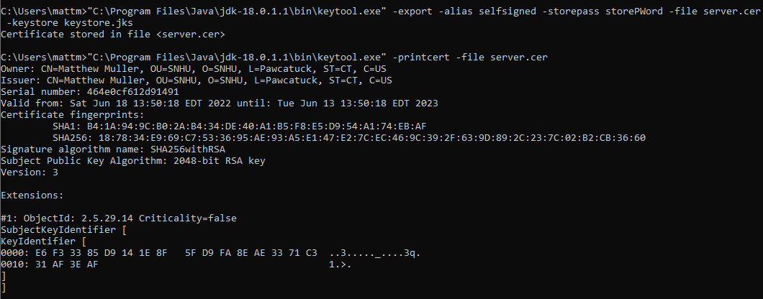

**Resources**

Sectigostorepages. (2021, September 1). Self signed certificate vs ca certificate - the differences

explained. SectigoStore. Retrieved June 18, 2022, from https://sectigostore.com/page/self-signed-certificate-vs-ca/#:~:text=A%20self%2Dsigned%20certificate%20is%20created%2C%20signed%2C%20and%20issued,the%20identity%20of%20the%20applicant.

Team, S. S. L. S. (2021, December 9). What is a Certificate Authority (CA)? SSL.com. Retrieved

June 18, 2022, from https://www.ssl.com/faqs/what-is-a-certificate-authority/